SECTION A: EDITORIAL OPPORTUNITY

Commissioning Owner | Will Wilkin
Commissioning Contact | Martha Ling
Commissioning Brief Title | The DC (working title)
Commissioning dept | BBC Music
Guide Price | Pilot Price: £11,000  Weekly on Commission: £15,000
Genre | Music/ Ents
Duration | 30-40 Minutes
No. of Ep: | Pilot Stage into 30 Weeks of Content (30 Episodes)

A1. Note from the Commissioner:
Culture moves at the speed you can scroll. U24s aren’t just watching or listening anymore; they’re saving, clipping, dubbing and sharing. They’re finding artists on TikTok, playlist building on Spotify, screaming Fleetwood Mac like it just came out, and booking Reading/Leeds, Glastonbury or TRNSMT the minute tickets drop. Eurovision is a big night in, a new Netflix series becomes a gateway to a new soundtrack, and the shows that cut through with them live right in that mix.
Podcasts for U24s have shifted too: from audio to visual, with format, pacing and personality doing the heavy lifting. We want a YouTube-first hangout show that sits in that flow and is easy to drop into because you like the people, the things they’re into, and the energy they bring. It’s clear that the right hosts are key to habit and weekly growth.
We'll take a handful of ideas into a pilot phase, working closely with the chosen supplier to shape the format, test chemistry and see what works on camera. One idea will move into a 30 episode run on its own YouTube channel. Financial incentives are tied to performance because the goal is simple: reach the right demographic.
Working with the BBC means fantastic access to artists, events and cultural moments and brand recognition that opens doors for creators and guests. This title will be YouTube-first and focused but will be leading the charge for visual podcasts on iPlayer.
We’re looking for a team who already speaks YouTube, who get how conversations move, how episodes build momentum, how casting makes or breaks it. Hosts who feel like themselves on camera: quick, curious, and plugged into how culture shifts through trends, feeds, fandoms and viral moments. Audiences know when something isn’t native to their feeds. Our values steer us, but the aim is to make a show people genuinely want to watch, share and come back to.
Thanks in advance for bringing your ideas and energy to this exciting new space,
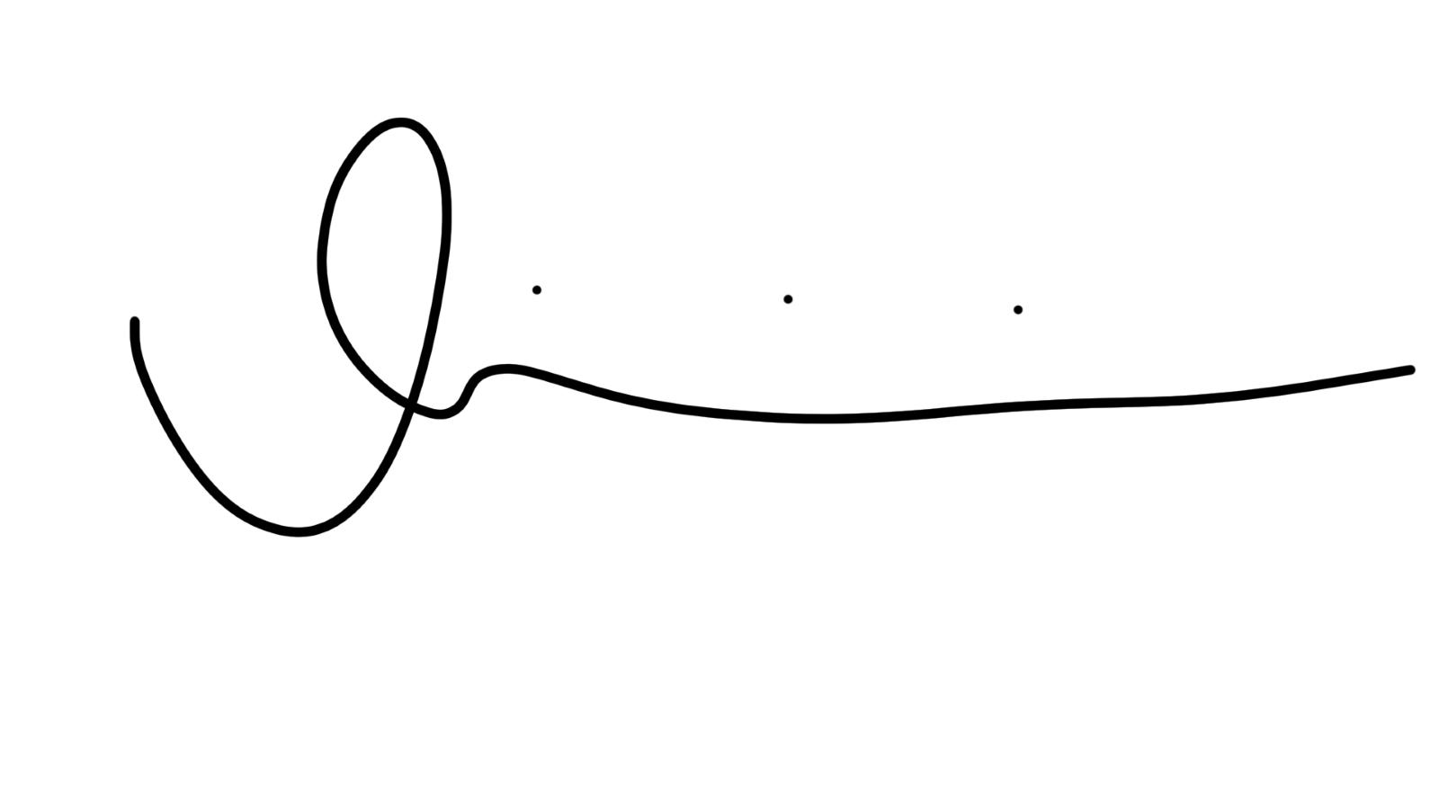
Will Wilkin
Commissioner for Music Podcasts

A2. Editorial Opportunity

A2.1 Vision

This YouTube-first podcast is designed to sit inside the online cultural conversation where music meets identity, fandom meets opinion, and the humour and honesty of internet culture drives everything. Rooted in music but not restricted by it, the show should move between chart trends, artist narratives, subcultures, fan theories, TikTok sounds and what people are actually listening to on the bus. It’s a visual podcast for people who experience music through culture and culture through music.
We want it to be habit forming: short, cutdown-friendly episodes that people want to spend time with, anticipate each drop, and dip back through the catalogue. The tone should feel like the group chat made real, smart, reactive, emotionally fluent and genuinely funny. It should reflect how Gen Z talk about music and culture: messy, enthusiastic, chaotic, sometimes deep, sometimes throwaway, always with passion! It should feel made within the culture, not observing it from outside. It can have guests if/when appropriate to the format.
Over time, we want both the title and hosts to be scalable. For example, the show can sit naturally as second screen content around major U24 moments the BBC covers festivals, live events, cultural nights where this audience already shows up. And while the BBC will maintain oversight and quality standards, the voice must stay creator native, informal and engaging.

A2.2 Tone & Format

The tone should be fast, warm, sharp and occasionally chaotic with a clear sense of personality driving each episode. The hosts should feel like people the audience choose to spend time with rather than formal presenters. Conversations can range from playful to profound, but humour is crucial. The format should allow for structure and repeatability (e.g. core segments or framing devices), but with enough flexibility to respond to what’s happening in culture each week. Episodes will be in the 30–40 minute range and must be designed from the outset as video-first, with clip led discovery baked into the concept. This is a podcast that must thrive on Shorts, vertical cuts, and community interaction.

A2.3 Host Identification, Development & Pilot Process
We want to work with suppliers who can shape this show from the ground up identifying and testing the right hosts, building chemistry on screen, and developing a format that feels natural, funny and repeatable. This isn’t about dropping traditional presenters into a pre-set structure: it’s about working with people who live in YouTube culture, can spot the voices audiences will connect with, and know how to build a show that feels alive in the feed.
Stage 1: Vision, Hosts and Format
In response to this brief, suppliers will be asked to set out a clear vision for how the show should work, the tone, the style, the core format, and the hosts who should front it. Consider how their current platforms and profile benefit the growth of the title. We’ll also ask for your eligibility to make this e.g. why are you the right production house with the relevant expertise.
Stage 2: Pilot Production & Testing
Once the commissioning process is complete a handful of suppliers will be conditionally commissioned to produce pilot episodes to test chemistry, format shape and short-form video potential.
Stage 3: Full Production & Launch
If the pilots demonstrate the right level of audience connection in testing, editorial clarity and value, the final line-up and editorial spine will be locked, and the title will move into full production. Weekly episodes will launch on a dedicated YouTube channel, supported by Shorts, TikTok and Instagram cutdowns to drive discovery and community building.
A2.4 Platform & Discovery Strategy

The show will be published on a single title brand BBC owned YouTube channel delivered in partnership with the production house, with Shorts and visual cutdowns used as key discovery tools. Additional to this channel we’ll work in partnership to grow the audience reach using YouTube, TikTok, and Instagram accounts. It must be fully native to the tone, pace, and visual grammar of these platforms.

A2.5 What are we trying to achieve?

- Build a creator native visual podcast brand that that builds a community episode to episode
- Create a multiplatform brand that reflects how under-24s experience music through culture, fandom, humour, and identity not just criticism or commentary
- Establish unique and consistent hosts that become part of the wider online music conversation: smart, emotionally fluent, and culturally current.
- Identify and develop breakthrough on-screen hosts who connect with this audience in an authentic, creator native way.
- Position the podcast as a key digital asset within BBC Music, attracting high-profile guest access, artist participation, and interest from labels.

A3. IP, Commercial & Licensing
Rights, Revenue and IP Agreement:
The BBC retains ownership and control of the podcast’s brand, all associated branding assets, and official platform and social media channels (including YouTube, TikTok, Instagram), ensuring long-term brand control, consistency, and continuity of audience engagement. The supplier will retain ownership of the podcast format, including recurring features, editorial structure, and creative architecture.

Annual performance KPIs shall be agreed between the BBC and the supplier. The achievement or exceedance of these KPIs - which may include, but are not limited to, audience growth metrics and engagement benchmarks - shall trigger eligibility for performance-related financial bonuses, subject to BBC approval.

This commission is conditional upon the grant of commercial distribution rights (which includes RSS) to the BBC/BBC Studios, and revenue shares will be treated in accordance with Audio Terms of Trade unless otherwise agreed.

A4. Target Audience Profile

The primary audience for this podcast is under 24s who engage with content that has social relevance or direct creator recommendation. Their attention is earned through bold ideas, entertaining formats, and consistency. Content must feel made for YouTube. For this commission, the hosts are key, we need to be working with hosts who are already YouTube natives and are at the tipping point in their careers, moving from small to mid-scale creators with devoted followings to the next big multi-platform hosts.

A5. Key Deliverables

We’d like the successful suppliers to take on broad responsibilities across the production, from set-build and hosts consultancy to full visual and audio delivery. The deliverables are split into the following categories:

A5.1 Pilot Deliverables:

Whilst the pilots will not be public facing, we will be using audience testing groups to trial pilot ideas from a small number of suppliers.

The pilot stage deliverables are:

- 1 x 16:9 fully visualised episode, optimised for YouTube
- 3 x 9:16 social media edits, optimised for use on Shorts, Instagram and TikTok
- 1 x audio rip, delivered as it would be for use on BBC Sounds and RSS Platforms

Placeholder set design and branding may be used, but the pilots should give a clear sense of the hosts’ dynamic, the overall tone of the show and demonstrate how the content meets the objectives set out in section A2.5 above.

A5.2 Visual Deliverables:

Once a full series commission has been confirmed, the deliverables shall be as follows:

- Set design and build, prop dressing (Separate one-off budget to be provided by BBC)
- Press and artwork photography (Separate one-off budget to be provided by BBC)
- Artwork and branding design (in collaboration with the BBC)
- A weekly visualised episode, optimised for distribution on YouTube
- A weekly visualised episode optimised for distribution on iPlayer
- 2-3 thumbnail image options, optimised for YouTube
- 2-3 thumbnail image options, optimised for iPlayer
- A suite of social video assets per episode, optimised for use on TikTok, Instagram and YouTube Shorts

A5.3 Audio Deliverables:

- A weekly audio equivalent episode, delivered for RSS and BBC Sounds

A5.4 Channels & Account Deliverables:

As YouTube is the key distribution platform for this commission, it will have a bespoke channel for the title delivered in partnership with the BBC. The successful supplier will use their expertise in YouTube channel management to guide the development of the title, considering distribution strategy, use of thumbnails and best practice around titles and captions, chapterisation and community management. The YouTube channel for the title will be a key focus in terms of building an audience community around the brand and should feel like an extension of the hosts’ own profiles. As part of the commission, we would like the supplier to develop a repeatable, community building format, that can be activated across YouTube, Instagram or TikTok. The objective here is to build brand loyalty and retention, by making the audience feel part of a community around the title and its hosts.

A6. Diversity
Diversity & Inclusion is a priority for ALL of us. We want the BBC to be demonstrably the best organisation in the audio sector to work for and with; one which reflects the diversity of the UK; and where people feel welcomed, appreciated, respected, and can be themselves and produce their best work. We’d like suppliers to show how diversity and inclusion will be considered at every stage of the production from who’s in the room shaping the show, to who we’re developing on screen, to the stories and references that form the heart of the conversation. That could include how you’re building diverse teams, supporting emerging hosts, contributing to industry access, or aligning with the BBC’s Creative Diversity strategy.

A7. Sustainability
The BBC is committed to informing and inspiring listeners about how they, as individuals, can take steps towards more sustainable living. Your proposal should consider how the editorial and production methods contribute towards the BBC’s Net Zero strategy, you can read about this here.

A8. Compliance And BBC Editorial Guidelines

At all times, the brand must comply fully with the BBC’s Editorial Guidelines, ensuring that content reflects the standards, values, and tone of the commissioning network. The supplier will be expected to uphold these standards across all episodes, associated content, and branded channels. By submitting your proposal, you confirm acceptance of the key contract terms.

SECTION B: PROPOSAL REQUIREMENTS
This is a pilot-to-series commission: we’ll work with a handful of suppliers to develop and test a pilot episode - including audience feedback, before committing to full production. In PiCoS you’ll have 1000 words to show the editorial. Please include:

B1. Editorial Overview

B1.1: Concept Overview & Format
Give us a clear, compelling summary of your proposed show:

- What’s the central idea and tone?
- How does it reflect the swirl of music, fandom, humour, and identity that defines Gen Z culture?
- What’s the week-to-week format: conversation, games, reaction, storytelling, or something else?
- How does it drive talkability, shareability and recommendation?
We’re open to bold, format breaking ideas especially those that feel native to YouTube and social platforms.

B1.2: Hosts
Hosts are central. We’re looking for hosts or contributors who feel authentic, funny, and culturally fluent; not polished presenters, but people with presence, opinions, and the ability to spark conversation.
Please include:

At least two host/hosts suggestions, with a short rationale for each.

Where relevant, expressions of interest or early conversations with hosts

Your approach to casting and chemistry testing during the pilot phase.

B1.3: Visual Approach
This is a visual-first commission. We want to understand:

How you’ll design the look and feel of the show - set-up, style, energy.

How you’ll balance authenticity with visual quality.
We’re especially interested in ideas that feel like a hangout, warm, informal, and visually engaging. Please feel free to include visual references, mock-ups, or mood boards if helpful.

B1.4: Community & Social Strategy
This show should live beyond the episode. Tell us:
- How you’ll build and nurture a community around the show.
- How you’ll work with the hosts to amplify the show across platforms
- Examples of past success in growing youth facing brands or fan communities.
We’re looking for strategies that feel organic, creator-led, and designed for discovery, not just promotion.
B1.5: Culture, Production & Standards
Please provide a concise overview of how your team will deliver the show to the highest level in regards to:
- How your company reflects diverse backgrounds and embeds inclusive casting, storytelling, and production practices.
- Your core creative and production team, their experience, and your capacity to produce consistent, adaptable, high quality content.
- Your understanding of BBC Editorial Guidelines, compliance, health & safety, and ability to meet evolving requirements while maintaining creative integrity.

B2: PRODUCTION ELIGIBILITY QUESTIONNAIRE

Please outline your relevant production experience, using recent examples, in the areas outlined below. Please prepare your responses in a word document and attach in PiCoS in the ‘Supporting Media’ section of your proposal.
2.1 We require a production base with relevant experience and staffing depth in video production for YouTube, particularly within the entertainment and music space.
[Insert details – max 250 words]
2.2 We require a production base with relevant production team knowledge and experience of working directly with a diverse range of online creator hosts.
[Insert details – max 250 words]
2.3 We require a production team with strong current relationships with record labels and artist teams, as well as an understanding of the BBC’s current Music offer.
[Insert details – max 250 words]
2.4 We require a production base with a clear understanding of how to successfully identify and launch new visual format ideas, including recent experience of working cross-functionally with internal and external stakeholders to build impactful distribution strategies around each episode and maximise audience reach across platforms.
[Insert details – max 250 words]

B3. Summary & Key Points

This is a pilot to series commission. The pilot will be audience tested before full production is greenlit.
- The show is YouTube-first, with global audio distribution via RSS and wider availability on BBC Sounds and iPlayer.
- The BBC will own the brand and channels; the supplier retains format IP.
- We’re looking for multi-platform potential ideas that can flex across formats, hosts, and communities.
- Visual entries, mock-ups, and creative references are welcome.
- Proposals must be submitted via PiCoS against ‘The DC’ round (Brief number 104017) for OD Sounds Music and include:
  - Two host/hosts suggestions
  - Topline visual and audio production plan
  - Examples of audience development work
  - Expression of interest from any non-BBC hosts
  - Responses to the Production Eligibility Questions outlined above, supplied as a separate attached document in the ‘Supporting Media’ section of PiCoS
- If you are registered with the BBC as a TV supplier, not an audio supplier, please contact PiCoS Support (picos.support@bbc.co.uk) and let them know you would like to pitch to this round
- If you are new to pitching to the BBC, you will need to complete a PiCoS Registration form so please ensure you allow enough time to register as you cannot submit a proposal before this stage.
- Suppliers must not approach current BBC hosts without written approval.
- We welcome proposals from production companies that support the BBC’s strategic rebalancing of production away from London, either from the outset or with a credible transition plan in the first year of the contract.

Areas that will be considered when evaluating pitches will include editorial proposal and capability, diversity and inclusion, planning management and production capacity, location, value for money and risk.

SECTION C: TIMELINE

C1. Proposal and Commission Timeline
Stage | Date/Duration | Activities
Brief Issued | 4th December | Brief published. Commissioning round opens in PiCoS - ‘The DC’ brief for Sounds OD Music
Proposal Deadline | 22nd January | Written proposals and eligibility questionnaires submitted.
In Person Pitches | w/c 2nd February | Either on Microsoft Teams or in person at BBC London Broadcasting House
Conditional Commissions Awarded | w/c 9th February | Final decisions communicated.

C2. Development & Pilot

Stage | Date / Duration | Activities
Format Development | Feb-March | Show structure, tone and set design refined; visual identity locked.
Pilot Delivery | w/c 16th March | Pilot episode filmed and edited with agreed hosts line up.
Launch | Early May | BBC and supplier review pilot and feedback; refinements agreed before full series sign-off.

