Easy Read Website

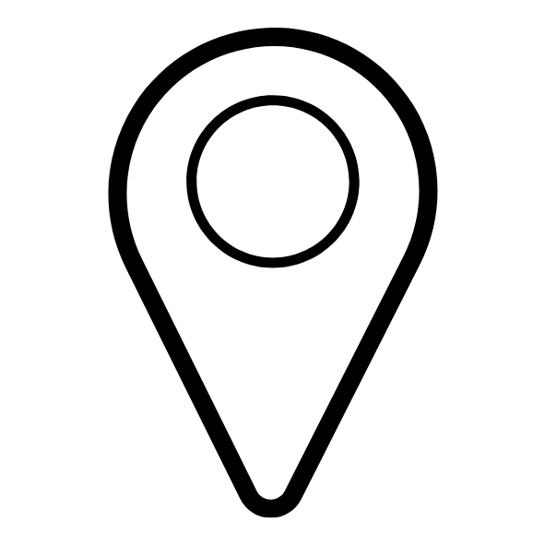  Location pin icon. | Location  Radio 1 Big Weekend is in Sefton Park, Liverpool.
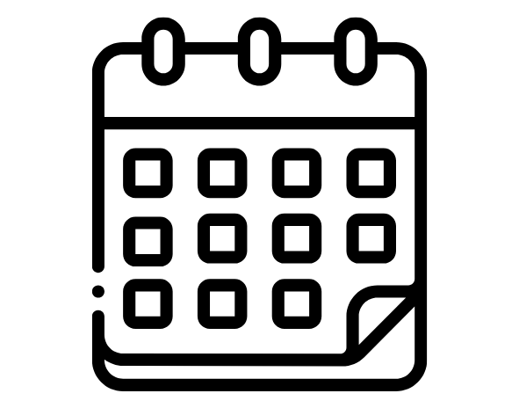  Calendar icon. | Dates  Friday 23rd - Sunday 25th May.
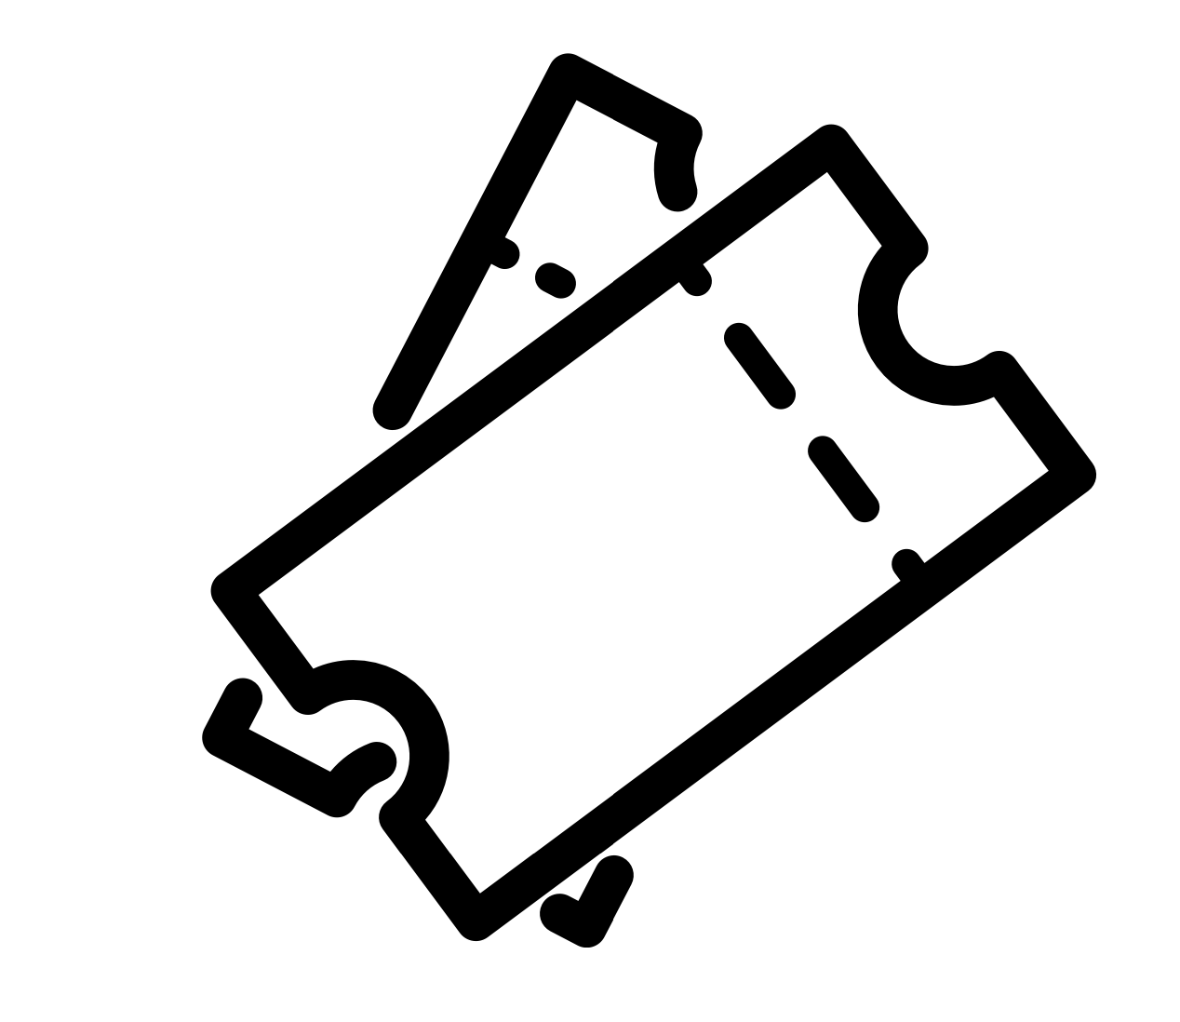  Ticket icon. | Tickets  Before applying for accessible facilities, please purchase your Radio 1 Big Weekend 2025 ticket.
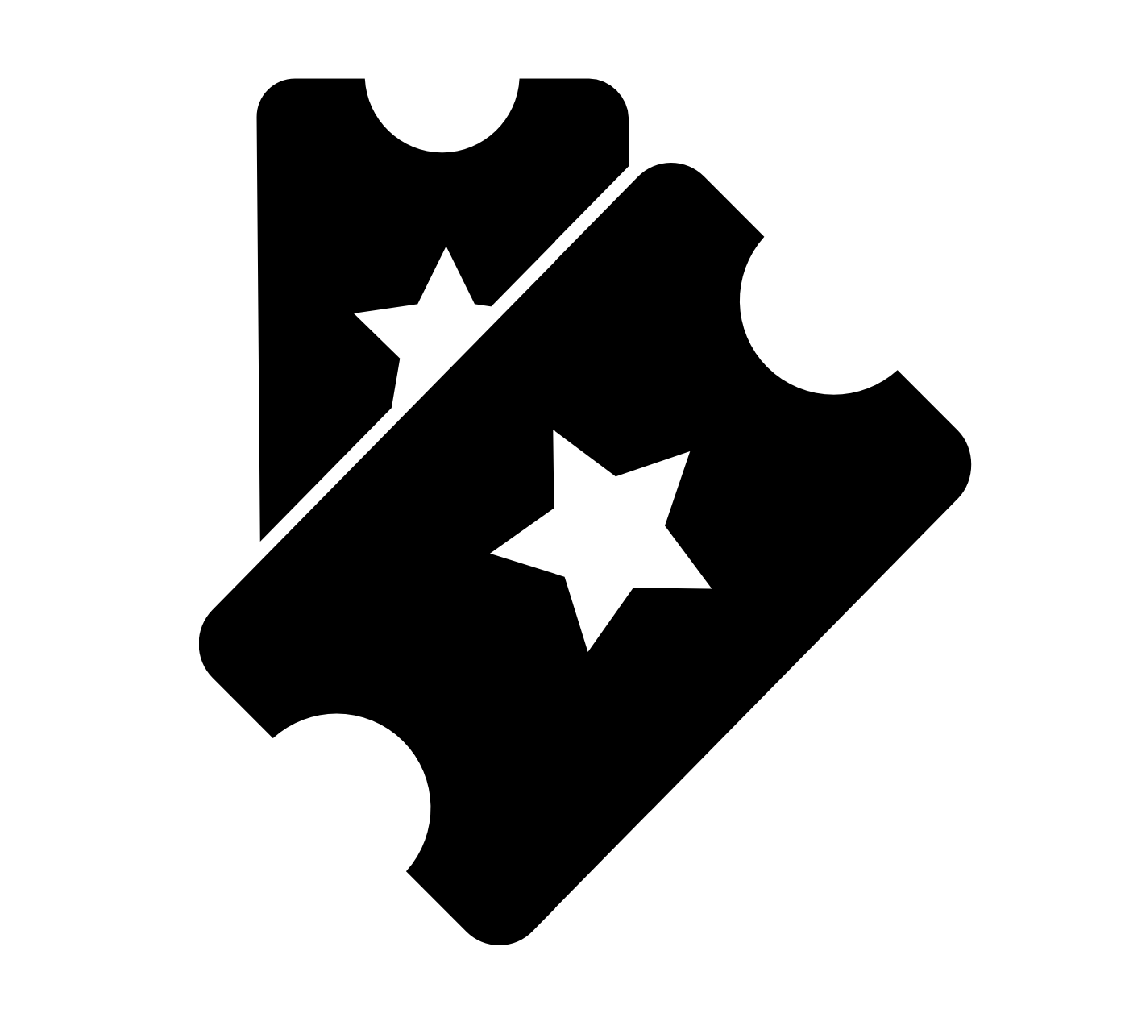  Ticket icon with stars on the tickets. | VIP Tickets  VIP tickets are £95.00 (+ £5.70 booking fee per ticket) per day.  You can buy these on the Radio 1 website here.
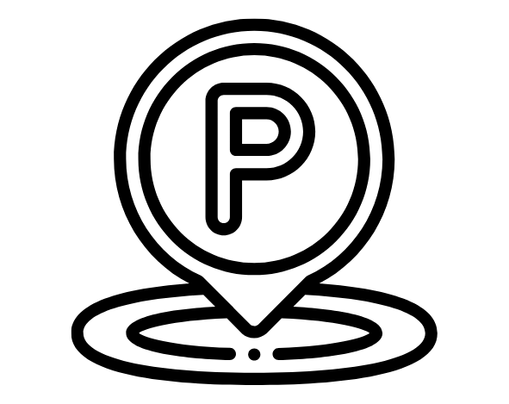  Parking icon. | Parking / Drop Off  There will be limited accessible parking available based on applications on a first come, first served basis.  Pick up and drop off points will be located close to site.
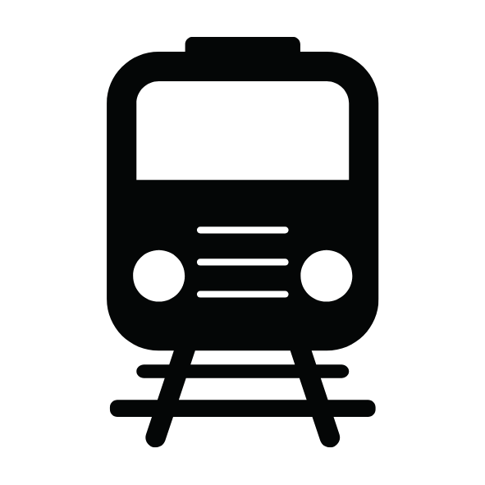  Train icon. | Public Transport  There are public transport options available, please see our Travel Page for more information.  Specific travel information will be sent out to accessibility customers ahead of the event.
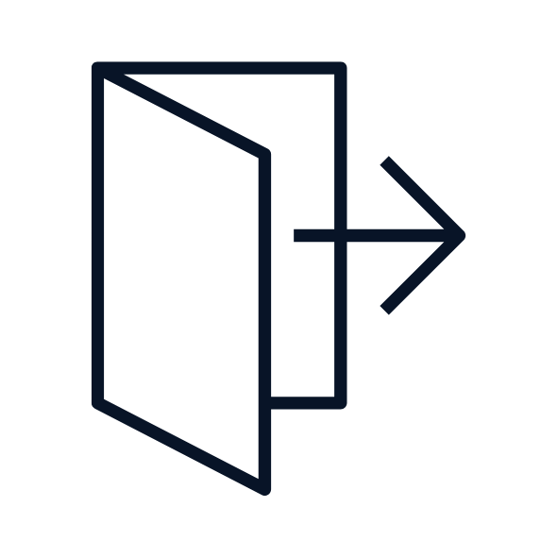  Icon of doorway with arrow pointing away from the doorway. | When is Last Entry?  On all event days, the last entry is at 20:45, and the events will end no later than 22:00.
  Icon of burger and drink. | Food  Food will be available at traders, including child friendly options and vegan, vegetarian and gluten free choices.
  Hot drink icon. | Drink  Hot and cold drinks will be available.  Alcohol is NOT permitted to be taken into the event.
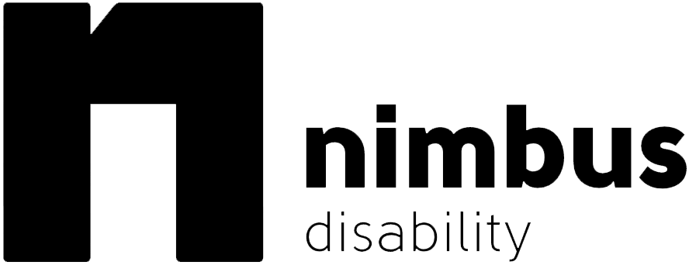  Nimbus Disability logo. | Nimbus Access Card / Digital Access Pass  Every customer wishing to make use of the accessibility facilities at Radio 1 Big Weekend, must have an existing Nimbus Access card, or can apply for a free digital pass for this event following the link on our website.
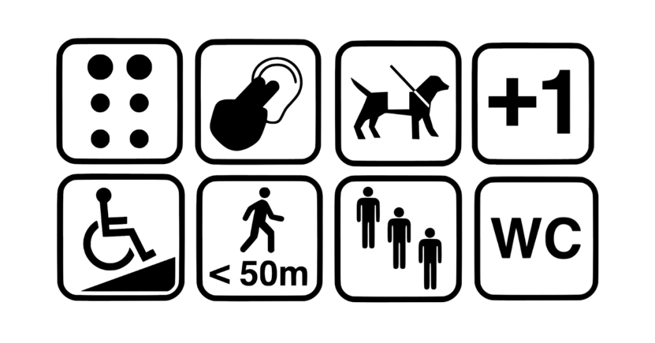  6 symbols representing different disabilities or impairments, such as the wheelchair access symbol, WC symbol, and assistance dogs symbol. | Nimbus Access Card / Digital Access Pass  Applications will be approved based on the symbols awarded on your card.
  Pen and paper icon. | Apply for the use of Accessible Facilities  Upon receipt of your confirmed Nimbus pass, please complete the Radio 1 Big Weekend accessibility application.  Accessibility applications will go live on Thursday 20th March at 09:00, the link to apply will be added to the website then.
  Crutch icon. | Temporary Impairments  Temporary impairments or short-term conditions such as a broken leg, infection or pregnancy cannot be facilitated within the accessibility application.
  Icon of two people next to each other. | Essential Companions  Do not purchase a ticket for your Essential Companion as they cannot be refunded after the application process.
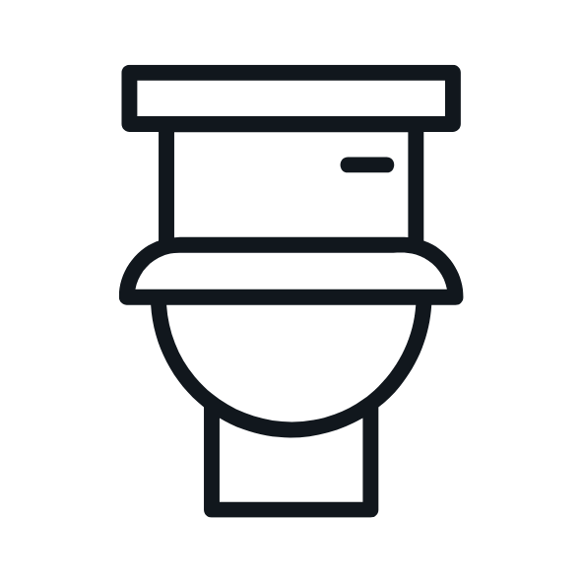  Toilet facility icon. | Accessible Toilets  Wheelchair accessible and standard toilets will be available across the event site and close to the viewing areas.
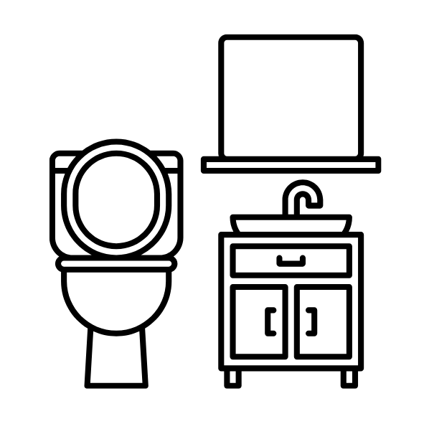  Icon of toilet facility with mirror and sink next to it. | Changing Places Unit  A changing places unit will be available and will include an adult changing bed, toilet sink and hoist. Please remember to bring your own hoist slings as they will not be provided. Find out more about Changing Places Facilities.
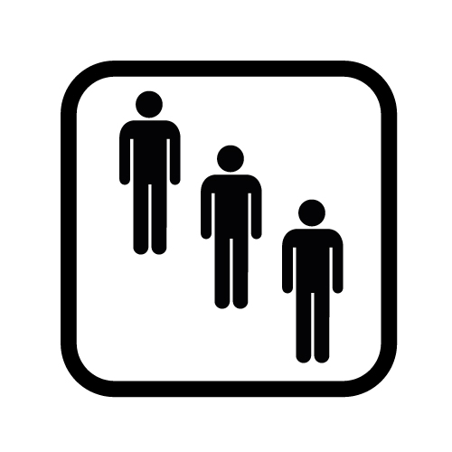  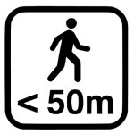  +  Or  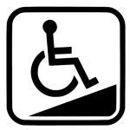  Diagram showing one symbol containing three people, which represents ‘standing and queueing’, next to another symbol of a person walking with < 50m written below it. A plus sign is in between both symbols.  Below this the diagram says ‘or’, followed by a wheelchair access symbol. | Raised Viewing Platform  The raised viewing platform is approved based on having both the below awarded symbols on your Nimbus Access Card.  - Standing and queuing symbol + short distances symbol.  - Or, the wheelchair symbol.  The raised viewing platform is intended for wheelchair users and those with restricted mobility.  The raised platform will have:  - Ramped access  - Wheelchair charging points  - Accessible toilets  - Drinking water refill point  The platforms are operated on a first come first served basis on the day.  Seating will be available.
Or  Diagram showing one symbol containing three people, which represents ‘standing and queueing’, next to another symbol of a person walking with < 50m written below it, with ‘or’ written in between both symbols. | Ground Level Viewing Areas  The ground level viewing area is approved based on having both the below awarded symbols on your Nimbus Access Card.  - Standing and queuing symbol  - Short distances symbol  It is an area intended for people who cannot stand for long periods of time, or need a space away from the crowded areas of the event.  The viewing areas are positioned in front of the raised platforms so do not provide an uninterrupted view of the stage.  The viewing areas are operated on a first come first served basis on the day.  Limited seating will be available. You are welcome to bring your own camping chair if it is approved and use it within this area only.  The ground level viewing areas are not covered, so please bring appropriate clothing for hot weather, cold or rain. Please note that golf / large umbrellas (1 metre or more) are not allowed onsite.
  Icon of an arrow pointing into an entrance. | Accessible Entrance Lanes  Dedicated accessible entry lanes will be available at each of the below locations:  - Box Office  - Main Entrance  - All Main Bars  - Official Merchandise Stand
  Icon of a person with their legs crossed. | Sensory Calm Tent  A quiet, safe area for any customer who may feel overwhelmed, anxious or need to recalibrate.
  Heart with a plus in the middle icon, with two hands supporting the heart. | Medical and Welfare  First aid and medical facilities will be available throughout the event. If you do require assistance, and are able to, please make your way to the medical tent in the main arena. Otherwise, please make yourself known to a member of staff who will assist.
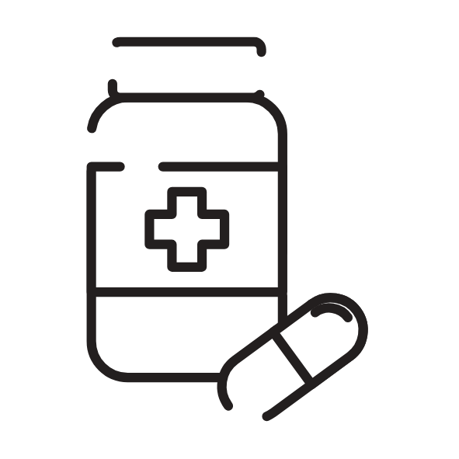  Medication bottle and pill icon. | Medication and Essential Medical Equipment  To make your arrival easy and avoid delays, please:  - Bring your prescription or a doctor’s letter, and ID that matches your name and address.  - Keep all medication in its original packaging with your name on the label.  - Loose medication (not in its packaging) is not allowed.  - Only bring the amount you need for the day — no extra.  - Be ready to show these at the entrance if asked.
  Medical needle icon. | Sharps  Safe deposit of sharps or medical equipment can be found at the medical tent in the arena.
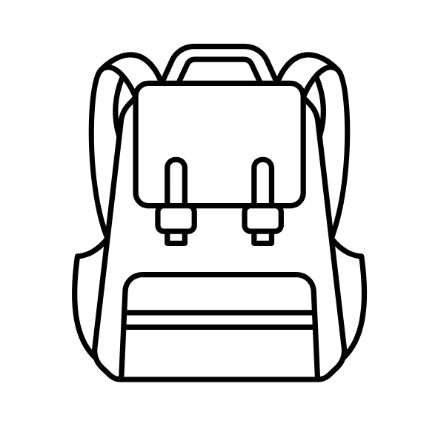  Rucksack icon. | Bag Restrictions  We recognise the need for some customers to carry essential items to assist with their needs at the event.  As such, accessibility customers only (not Essential Companions or guests) may bring a bag larger than A4. Please be aware that your bag may be searched on entry.
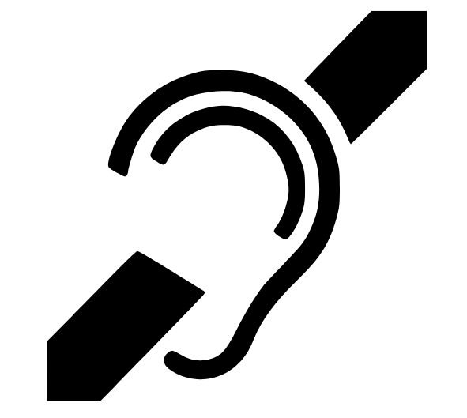  Deaf icon. | Deaf Customers  Induction hearing loops will be positioned at the box office, viewing areas and information hub.  For customers requiring BSL interpretation services, a free service will be provided on request.
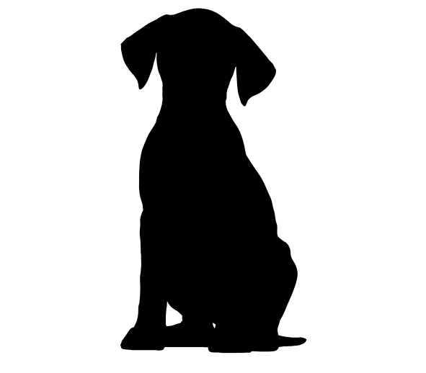  Dog icon. | Assistance Dogs  Assistance dogs will be approved as indicated on your Nimbus card.
  Email icon. | Contact  If you would prefer to speak to somebody, please email us with your name and contact information and we will be happy to arrange a time to call.

